Kirby in a Floatie



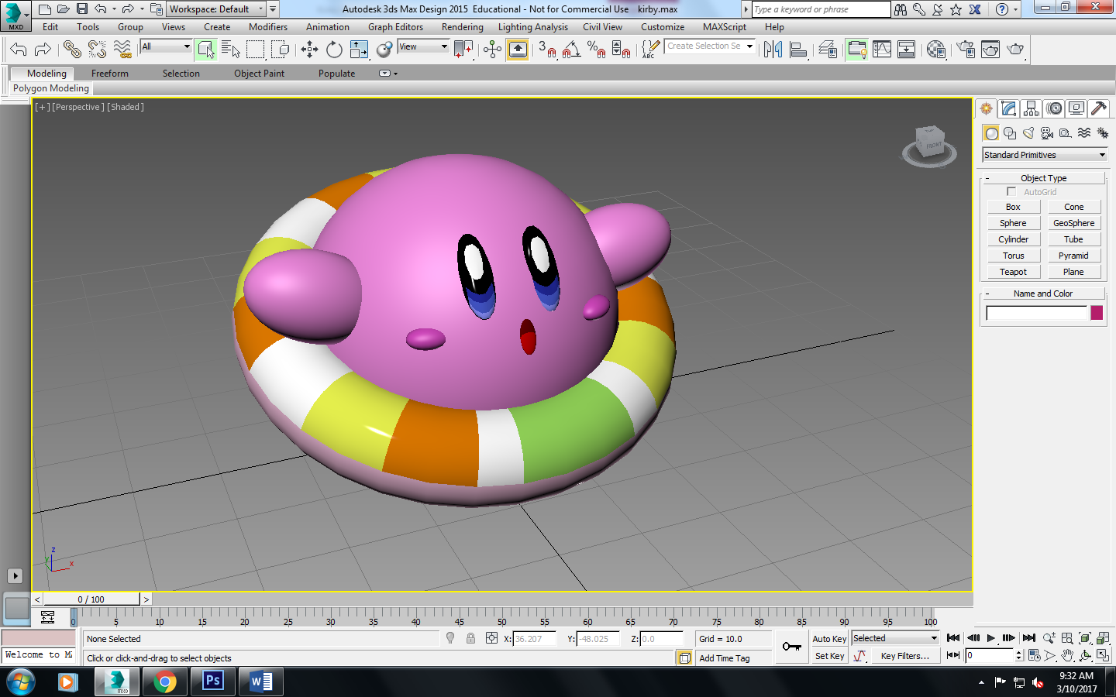

Body

1. Create a sphere that is radius 20.0 and has 32 segments.

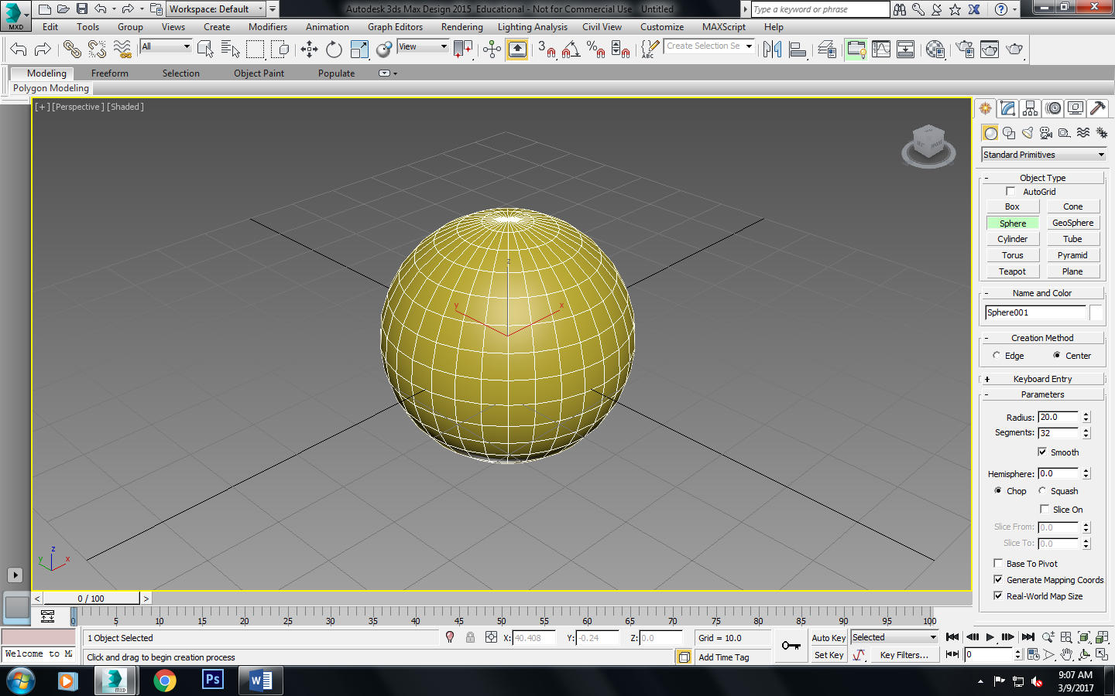

2. Go to material editor and change the color to pink.

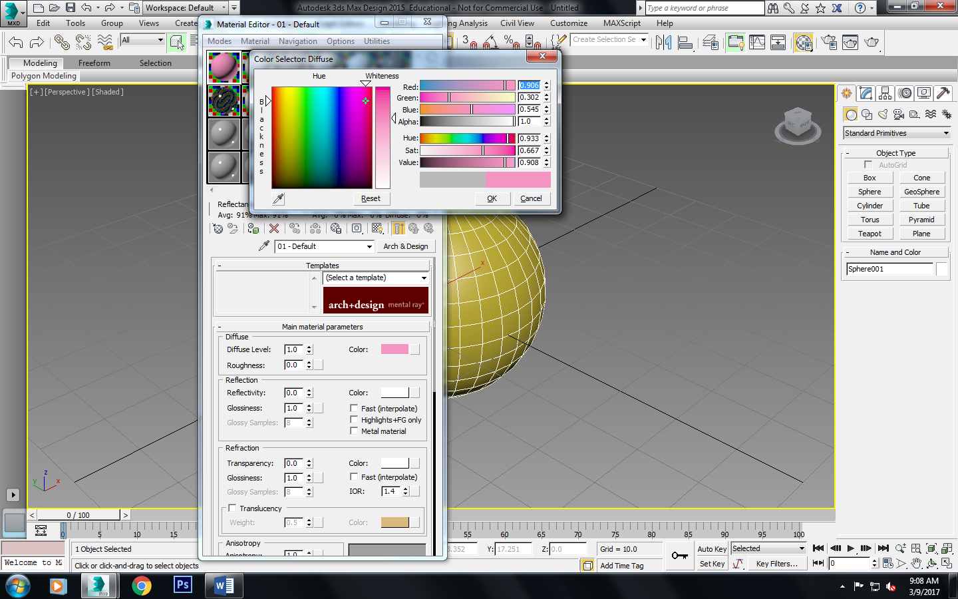

Arms

1. Make a sphere: radius 7.9, segments: 32
2. Use the scale tool on the top and squish it (click the R key to change it from scale, to a squish)

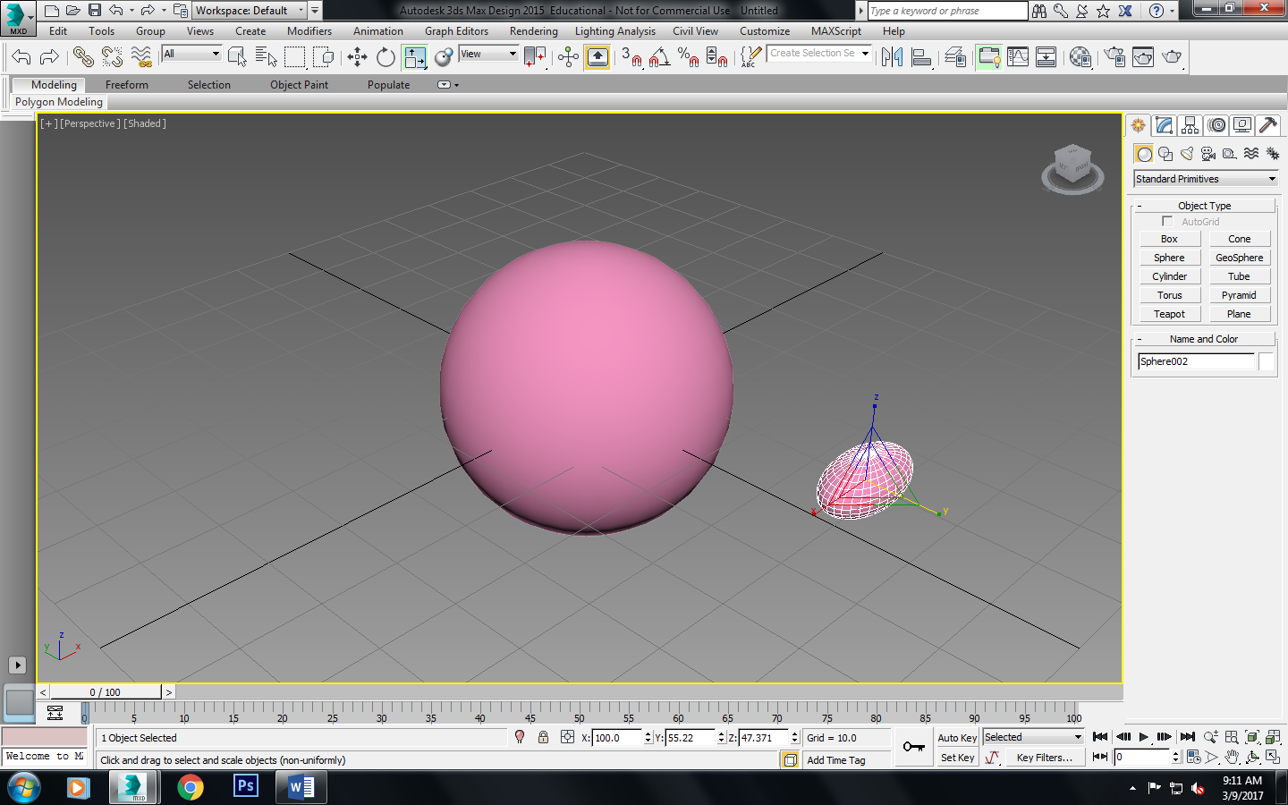

1. Then move it so it is at an angle like so (pic)

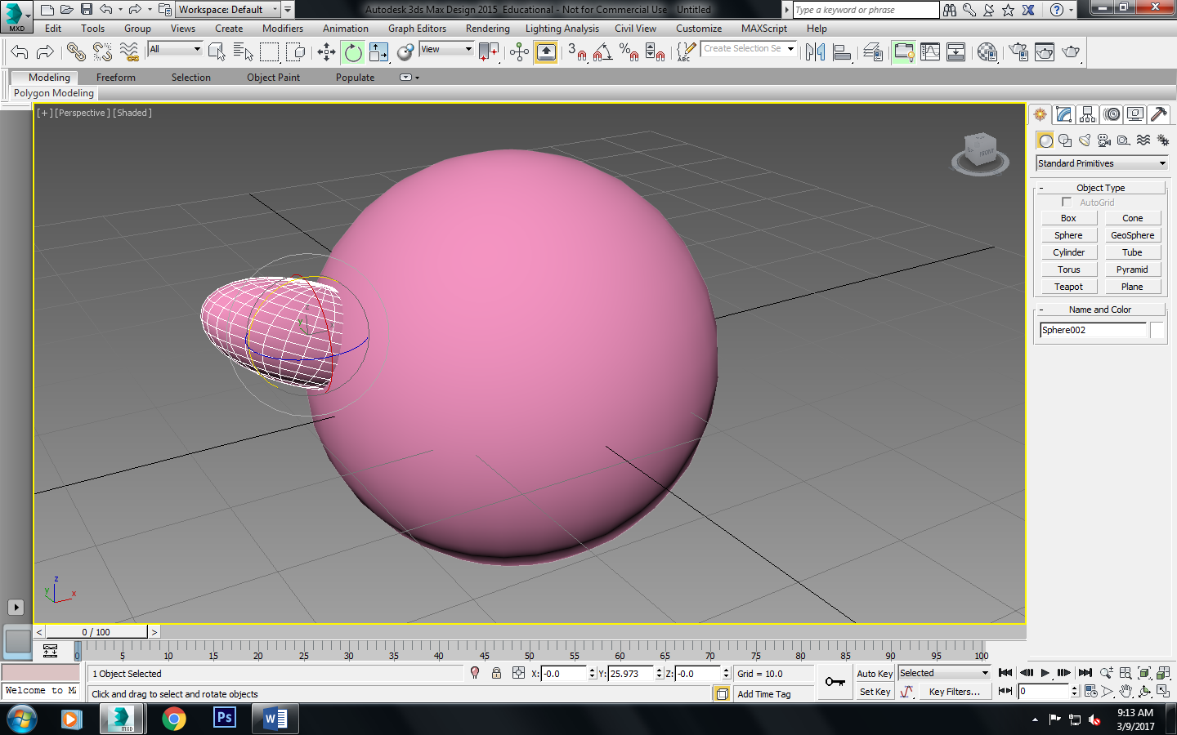

1. Make a copy of it so he has another arm on the other side, and rotate it again so it’s symmetrical. 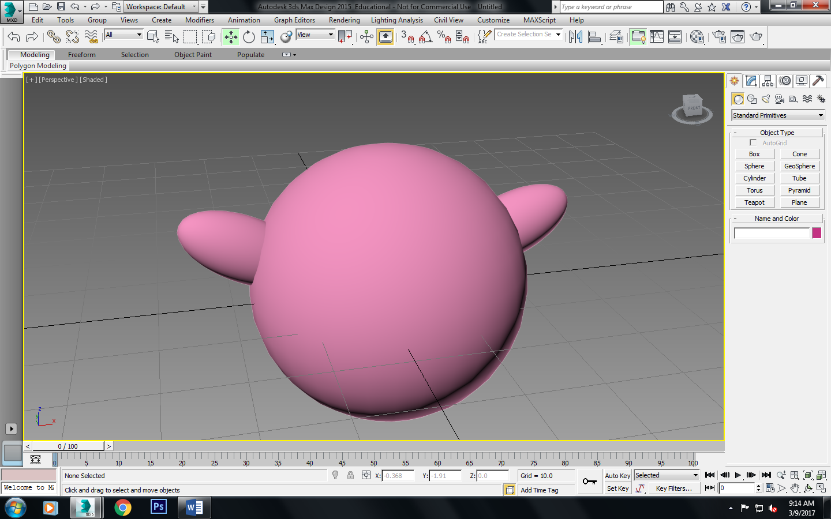

Swimming Tube

1. Make a torus and have parameters: radius 1: 22.16, radius 2: 5.735 and 33 segments.

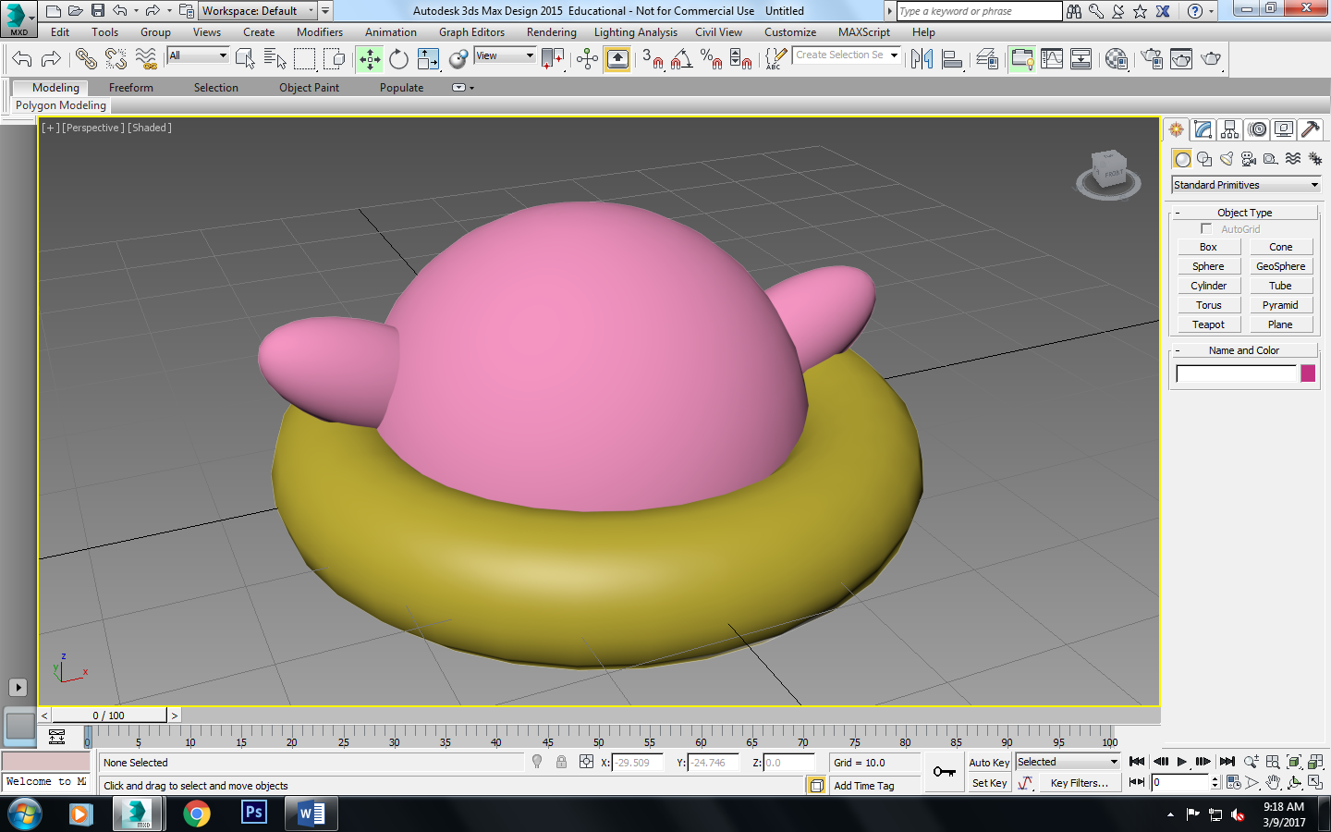

1. Make it so it is at an angle on the sphere, and under the arms.

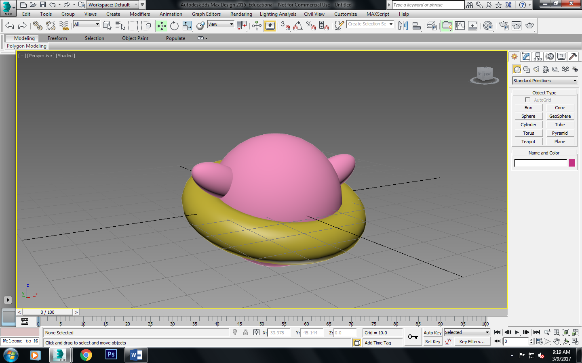

1. Make it so the tube has two different colors, one on top half and one on the bottom half. (Make it into an edible poly and click the top half to make it a color and same for the bottom.)

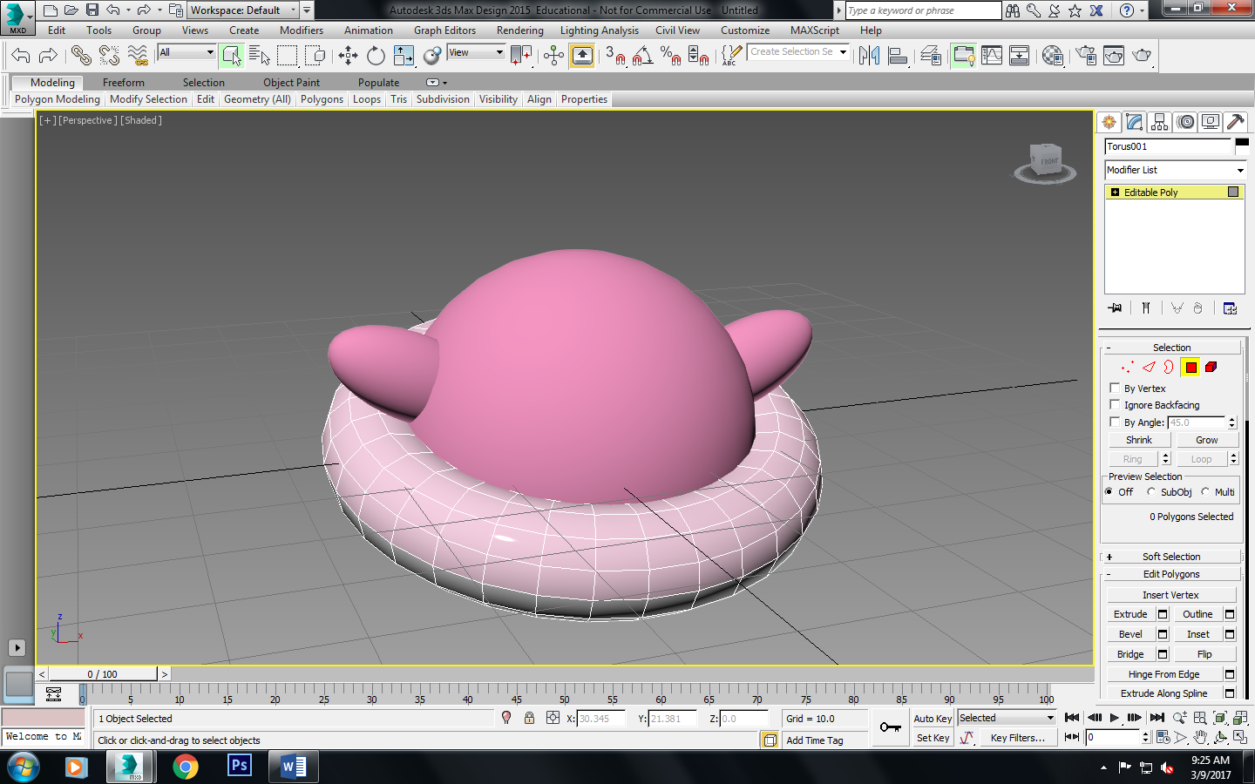

1. The top will have a pattern of white, and yellow, and a green stripe in the front. Use material editor to apply these colors into a pattern.

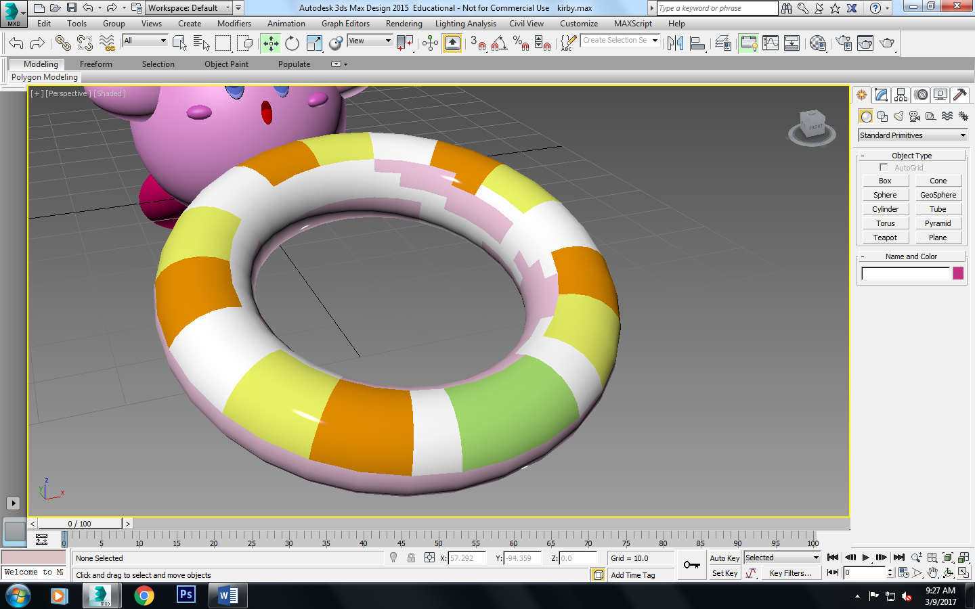

1. The bottom half of the tube will be light pink.

Cheeks:

1. Make a sphere radius: 2.259, segments of 18.
2. Make it dark pink like so:

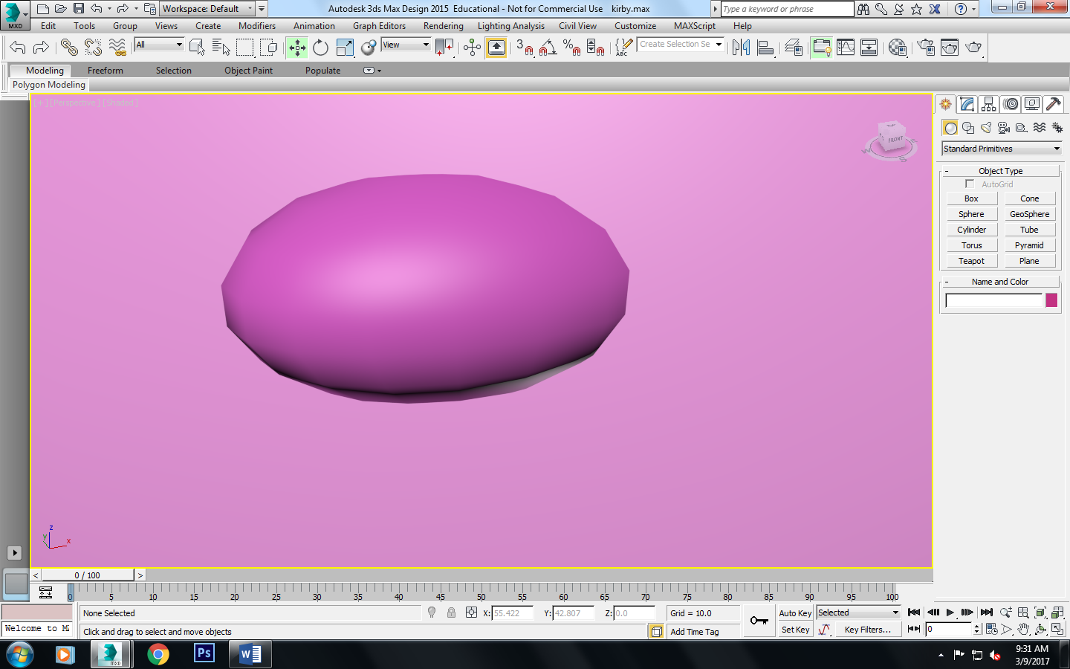

1. Put it on the face like so and then make a copy of it to the other side.

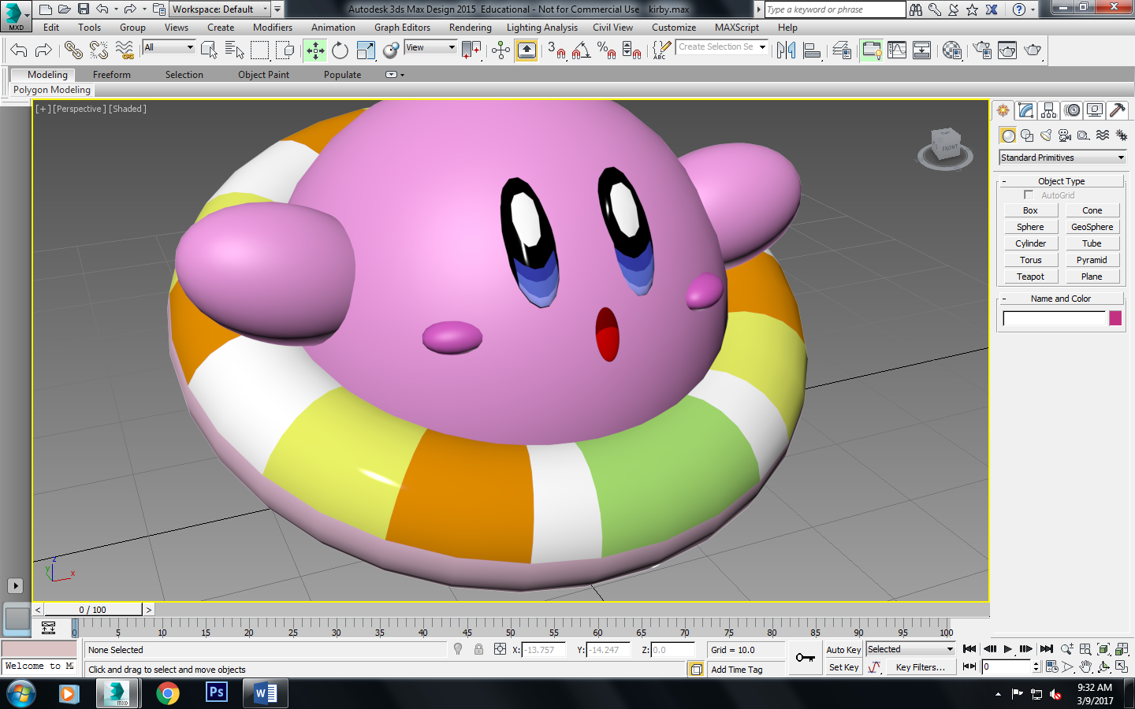

Mouth:

1. Make a sphere radius: 6 and segments: 18.
2. Use the scale tool again and press the R key to flatten it. (pull from the y-axis)

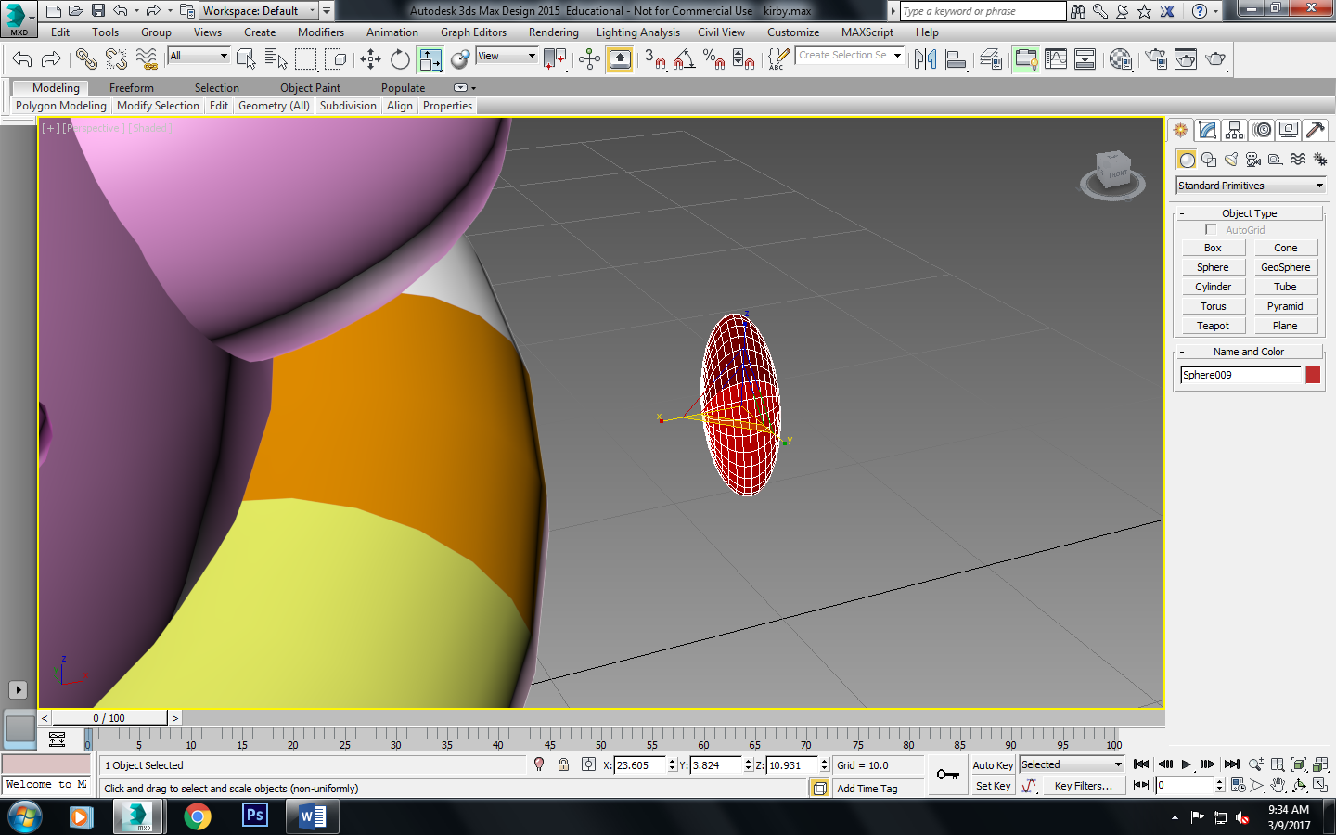

1. Then rotate it vertically like the picture above and apply it onto Kirby at an angle so it looks like it attaches on.

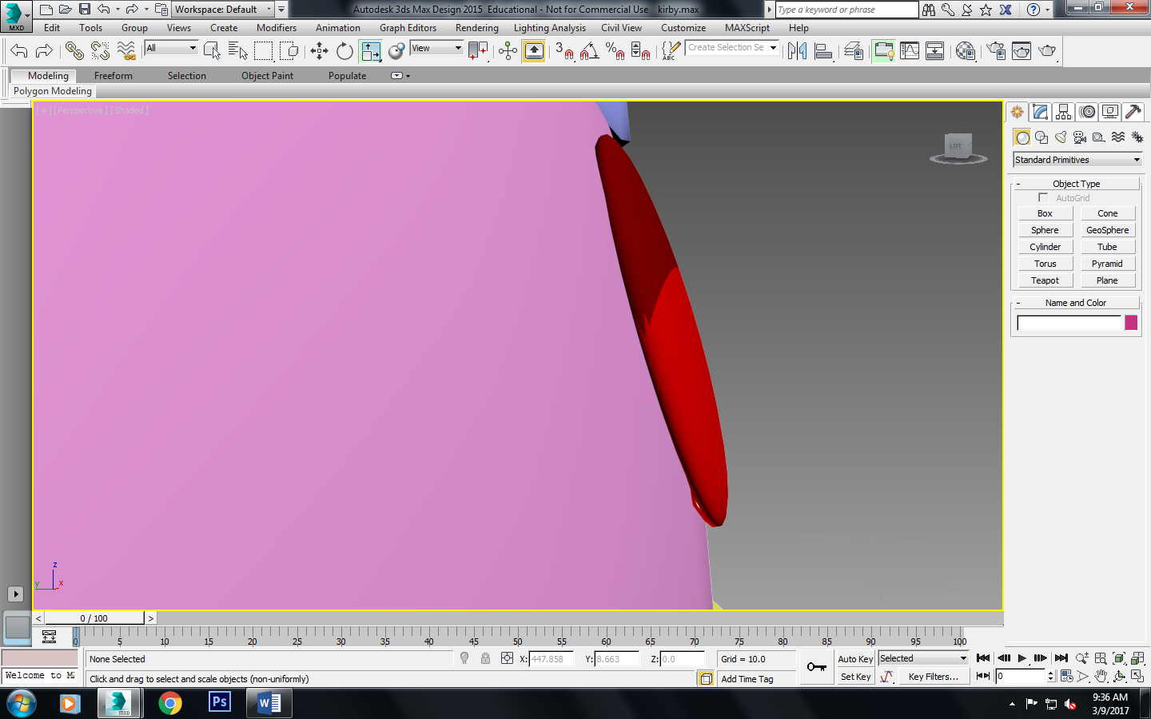

1. Make it into an editable poly and make the top half dark red and the bottom half a bright red.

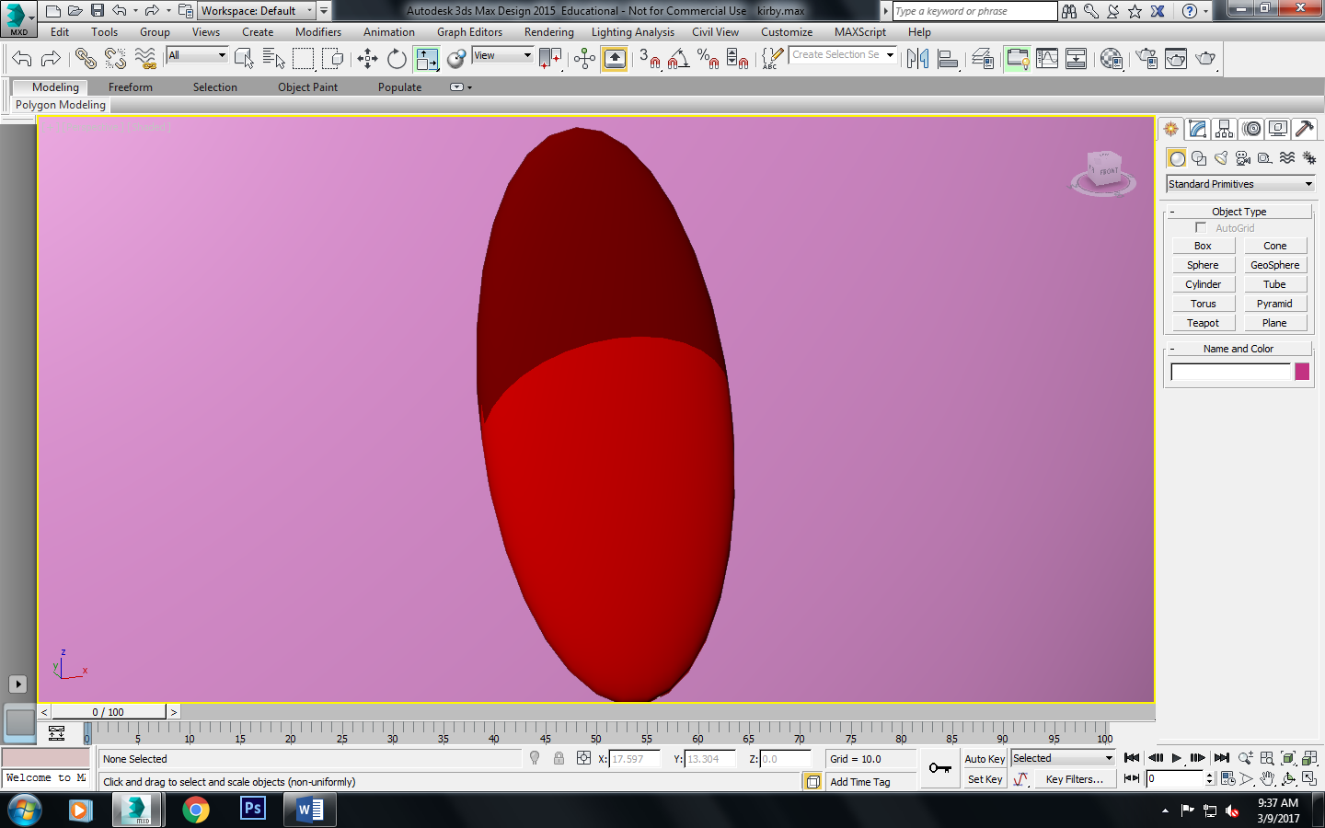

Eyes:

1. Make a sphere, radius 5.823, and segments: 32
2. Do the same step of what you did for the mouth using the scalar tool and press the R key and squish it.

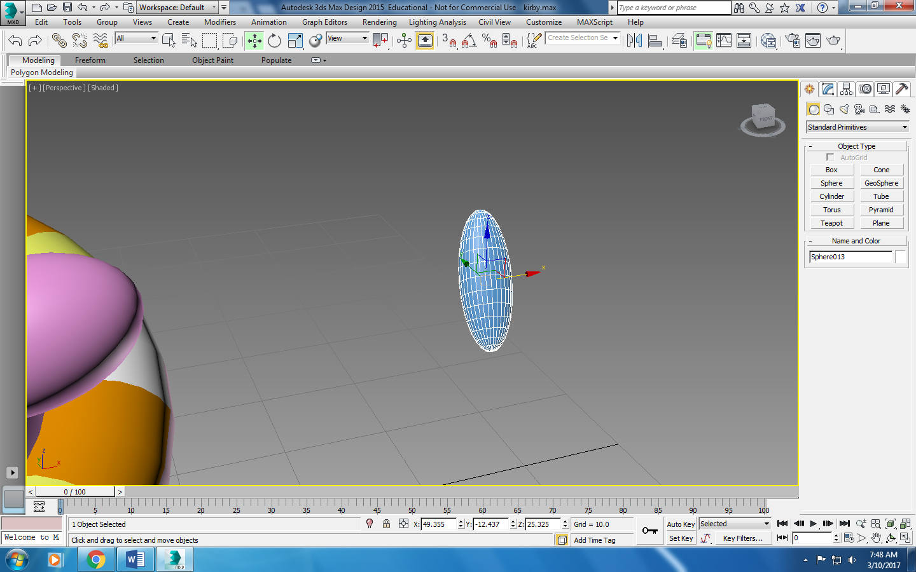

1. Move this using the move tool and place a little to the left and up from the mouth.

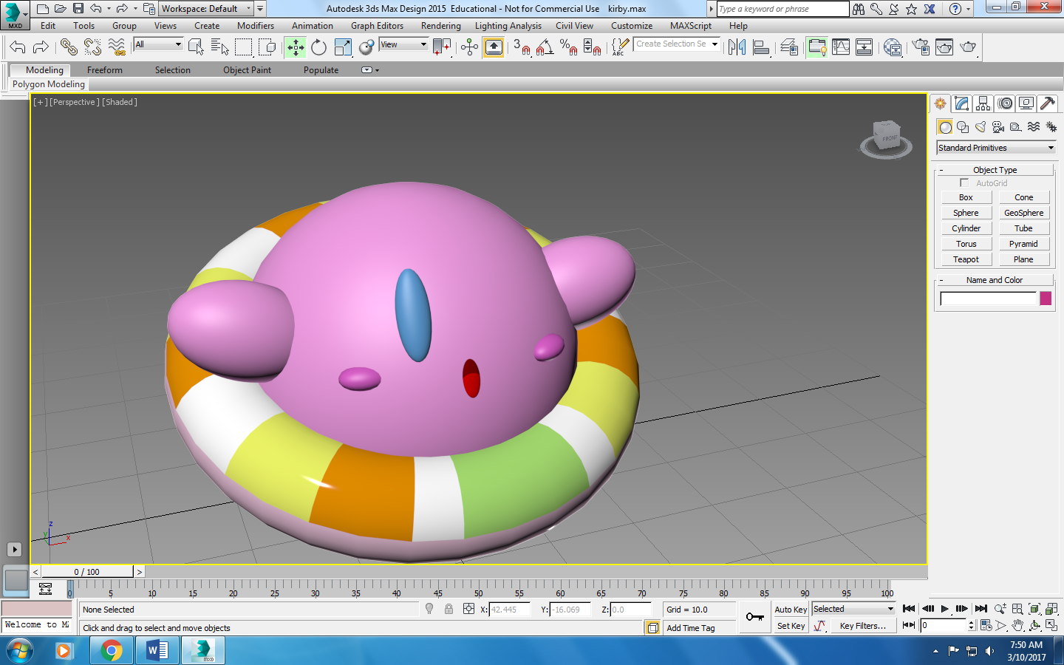

1. Go to material editor to make it completely black.
2. Make it into an editable poly and go to polygon and select the bottom part of the sphere so it is like a U shape like so.

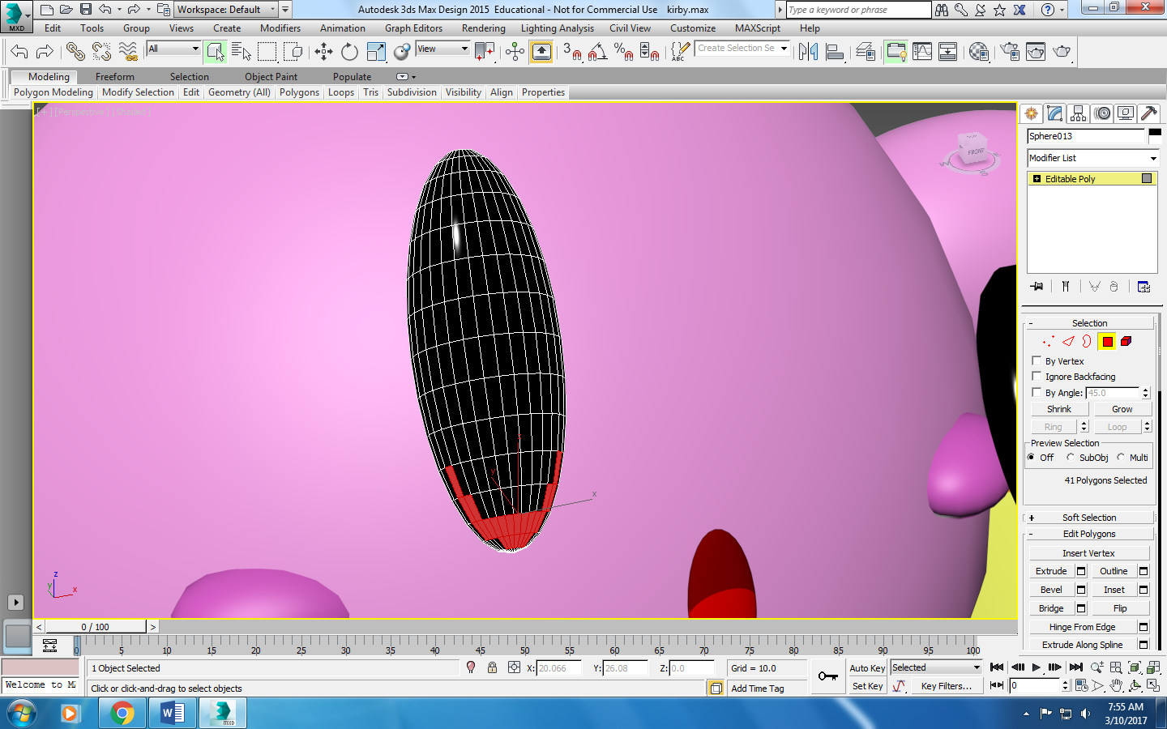

1. Go back to material editor and make this a light blue.
2. Make 3 U layers and make them look (as a whole) a gradient color like so.

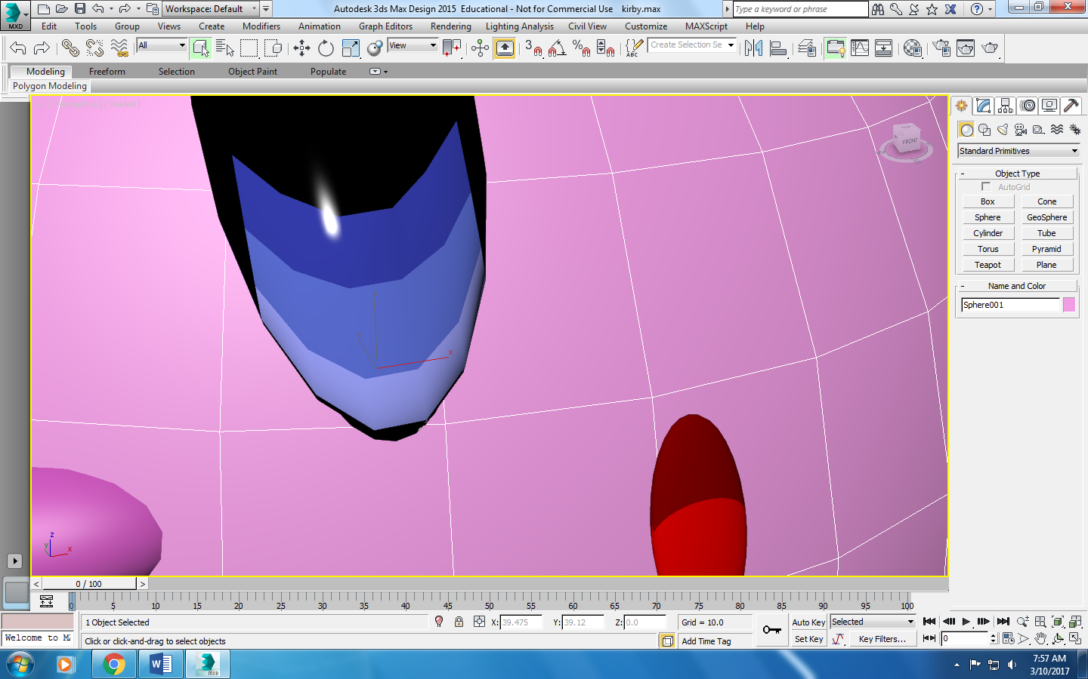

1. Once this is done, we need to do the whites/reflection of the eye. Use the vertex tool and the move tool to make it so there is a circular shape in between the U layers and the top/black part of his eye.
2. Color this white by using material editor.

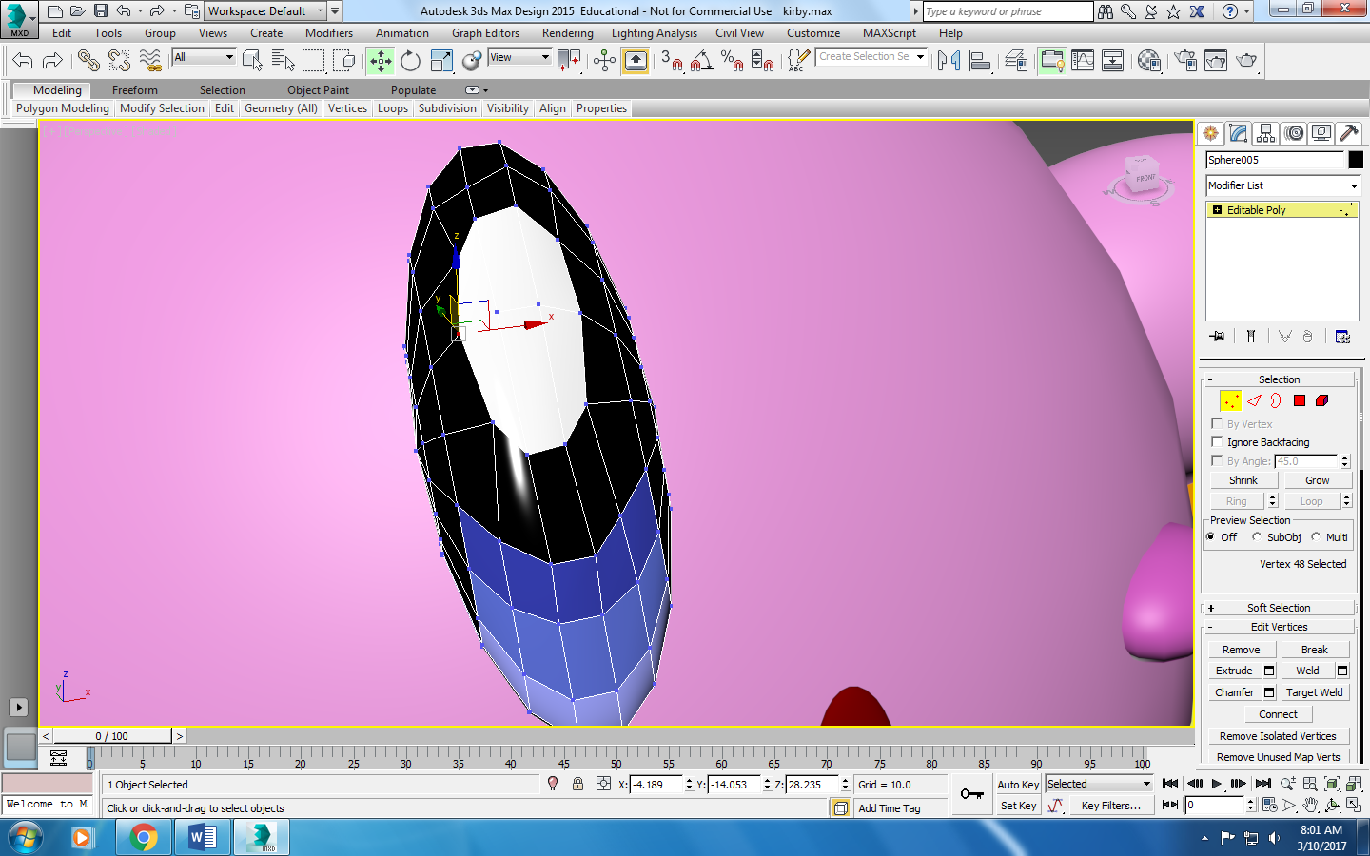

1. Make a copy by pressing shift and using the move tool so there is another eye on the other side.

Legs/Feet: 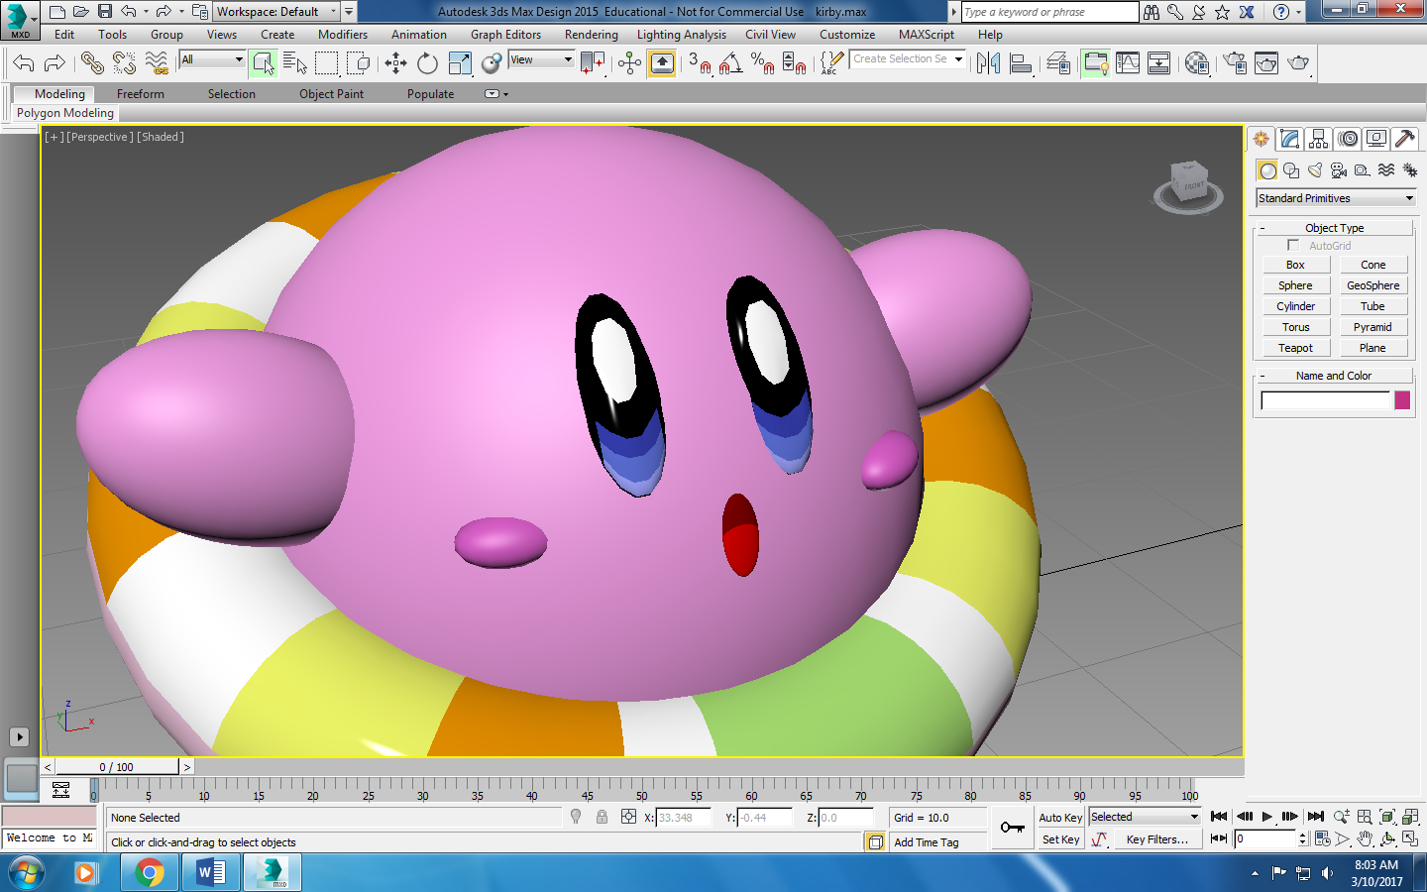

1. Create a sphere, radius: 9.869, segments: 32
2. Go to material editor and make it into a reddish-purple color.
3. Move it to the bottom of Kirby and attach it at an angle so it looks like he’s floating.
4. Create a copy of it and use shift to make another foot.

